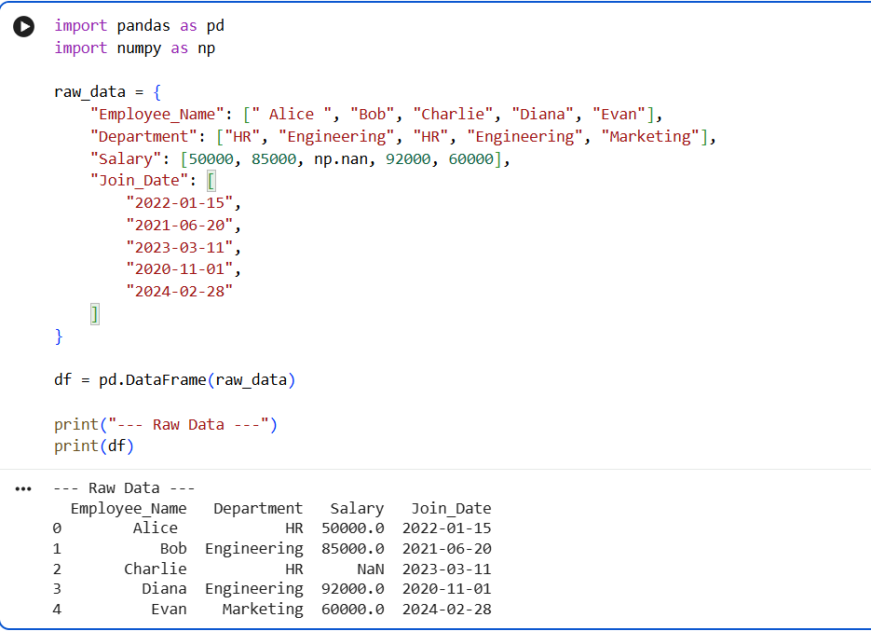
1. GENERATE RAW MOCK DATA

2. DATA PREPROCESSING
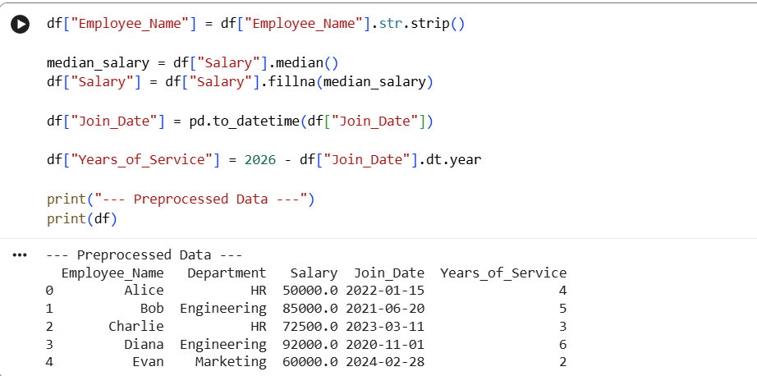

3. DATA AGGREGATION
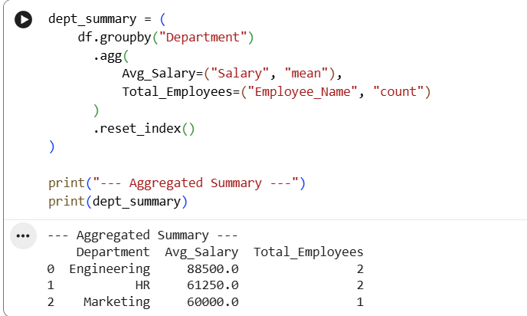

4. DATA VISUALIZATION
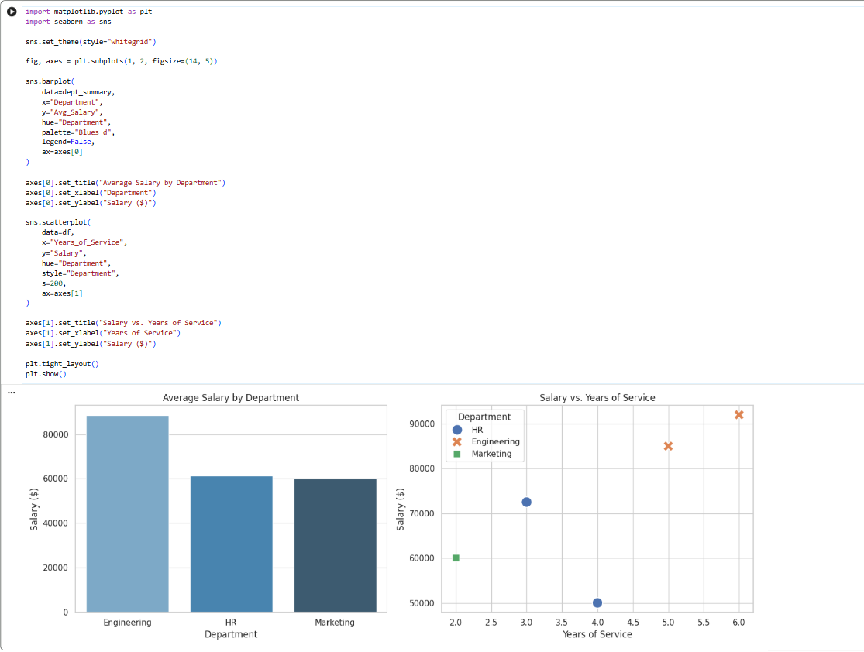

5. Creating Sample DataFrame
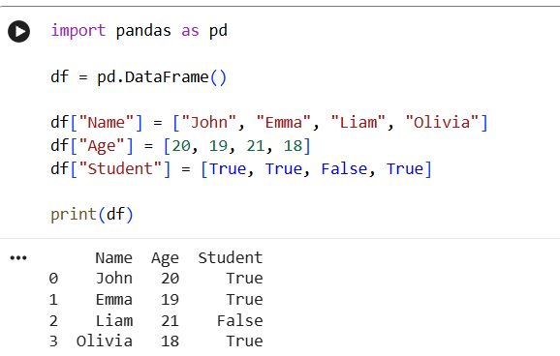

6. Adding Row to DataFrame
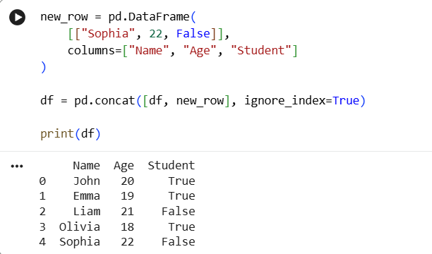
7. Measures of Central Tendency Using SciPy
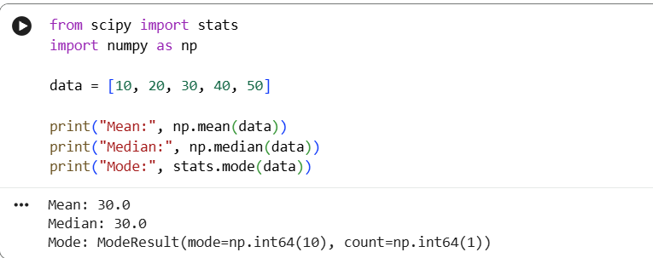

8. Probability Distribution Analysis Using SciPy
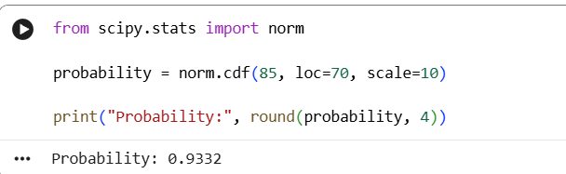

9. Hypothesis Testing
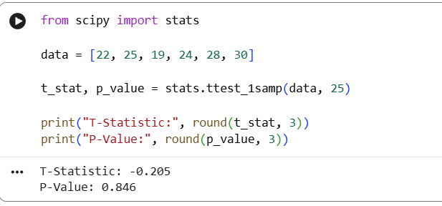
10. Correlation Analysis
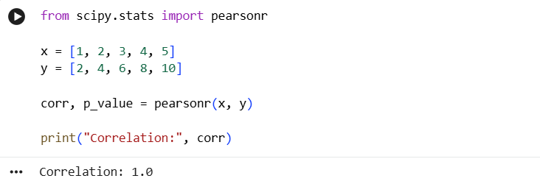

11. Linear Algebra Operations
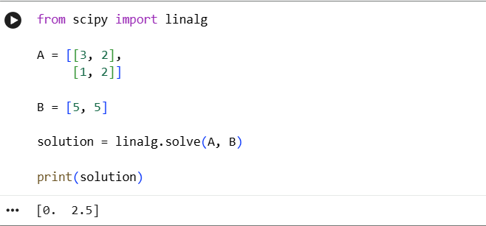

12. Optimization Using SciPy
